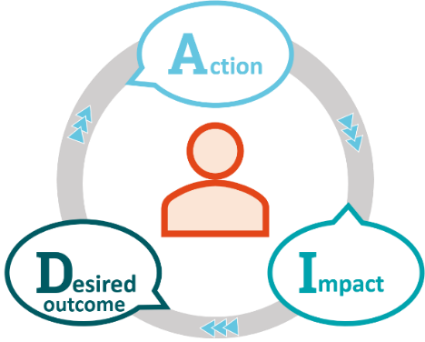Structuring your feedback by describing the **Action**, considering the **Impacts** and then relating them to the **Desired outcome**, can ensure that your perspective is clearly communicated - giving the recipient a clear action and enhanced motivation.

Consider who you should be giving feedback to this week both for great things done and to improve personal performance. Take time to prepare the feedback, use this template to support your preparation. This prep time will ensure that your conversaton will be clear, conscise and useful.

|  |  |  |
| --- | --- | --- |
| **Action** | **Impact** | **Desired outcome** |
| Emphasis is on the actions, not your interpretation of it. Feedback on what you observed or heard, not their intentions, their personality or character. | Explain the specific impacts of their actions. This can include positive or constructive impact on the result. | Identify the outcomes, build upon strengths or positives and what they may want to consider in the future. Ask for their suggestions regarding changes to actions or behaviours. |
|  |  |  |

Additional support if required. You can use the example questions and or statements below to prompt your preparation for your feedback discussion or to help you decide if it is better to introduce a feedback item as a question or statement.

